Name: ________________________________Date: ___________________________________

Class: _________________________________Teacher: ___________________________________

# Applications of Quadratics

### Warm-up

Your friend takes a video of you dropping a tennis ball from about 4m (12 ft) high. Using Python, you analyze the video and calculate the height of the ball from the ground versus time. The graph is below.

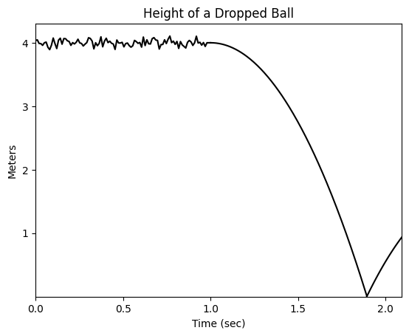

Using the graph, at what time do you think each of the following happened? Why?

1. the ball is dropped

*The ball is dropped right around 1 second. This is when the curve smooths and the height of the ball begins to decrease.*

1. When the ball hits the ground

*Right before 2 seconds. This is when the height of the ball becomes 0, indicating it’s hit the ground.*

1. When the ball is moving the fastest

*Right before the ball hits the ground. That’s when the graph appears to be the steepest.*

### Chucking a Ball

Your friend takes another video, this time of you throwing the ball on the football field. Using Python, you analyze the video and calculate the height of the ball and *how far away the ball was from you horizontally*. The graph is below.

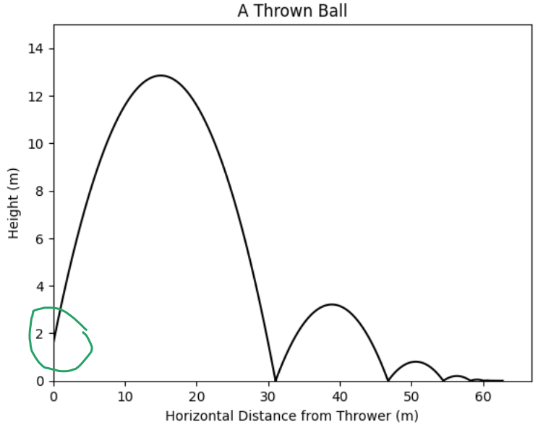

Using the graph, determine:

1. where on the graph the ball is thrown (circle it), *this is where the ball is 0m away from the thrower, meaning the thrower is touching the ball*
2. how far the ball traveled before hitting the ground: *just over 30 m, this is the first place where the ball hits the ground (y=0)*
3. about how many times it bounced: *5, this is the number of bumps that we see*
4. how far the ball was when it began to roll: *60m, this is where ball is no longer going up (stays on the ground, y=0) as it moves farther away*
5. how far the ball was thrown: *62-64 meters. This is the maximum x value of the graph, the farthest point that the ball reached from the thrower*
6. how far away the ball was when it reached its highest point: *About 15 meters. This is where the highest y-value was reached*

### 

### Chucking the ball extended

To the left are four graphs with ***time*** on the x-axis. Decide which graph goes with each of the following:

1. The height of the ball versus time: *b*
2. The distance from the thrower versus time. *a*
3. The vertical velocity of the ball versus time: *d*
4. The horizontal velocity of the ball versus time: *c*

*First, we know that the horizontal distance from the thrower is the old graph that never decreases. That’s to say, once you throw the ball, it doesn’t come back. The only graph that never decreases is a.*

*Next, we know that the height of the ball versus time will look somewhat similar to the distance versus time. It should have various humps, each hump indicating a bounce (or the initial throw). The only graph that looks like this is b.*

*Next, we know that vertically, the ball must go up and down. This means it must at some times have a positive velocity and at some times have a negative velocity. The only graph which has both positive and negative values is d.*

*Finally, the remaining graph is c, which must be the horizontal velocity of the ball.*

### Pollutant AQI

Wildfires can be dangerous for a lot of reasons. One of the reasons is that they emit harmful air pollutants into the air, for example PM2.5, fine particles that can negatively impact lunch functioning[1]. We want to understand how the pollution spreads in the surrounding environment from the *center* of the fire (not necessarily the edge). Governments often release a metric called the AQI (air quality index), a way of measuring the concentration of a pollutant in the air. The higher the AQI, the more of the pollutant there is and the more dangerous it is. Below is a chart of how harmful pollutants at each AQI are[2].

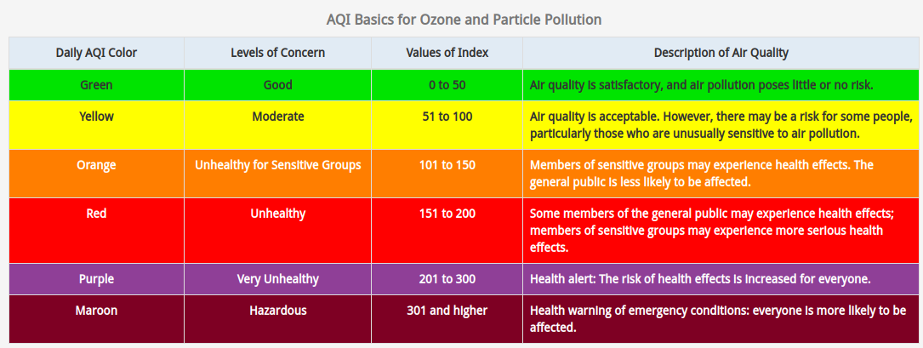

Image the AQI of PM2.5 in the air can be expressed as a quadratic function of the distance from the center of the fire. The graph is below. Answer the following questions about the graph

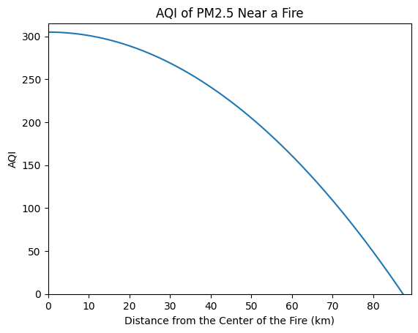

1. What does the x-intercept represent? The y-intercept?

*X-intercept: The AQI right at the center of the fire (0 km from the center)*

*Y-intercept: When the AQI reaches 0, where there is effectively no contaminant PM2.5 left in the air*

2. About how far from the center of the fire would someone with asthma need to be in order to be safe ? How do you know?

*Around 70 km. We would consider someone with Asthma sensitive to pollutants. So, the AQI needs to be at least as low as 100 (per the table above). This value is reached at just about 70 km.*

3. About how far away from the center of the fire would you need to be so that the fire poses very little or no threat to you ? How do you know?

*Having little to no risk is the green zone of the AQI, with a maximum of 50. The AQI reaches 50 at about 80 km from the center, meaning 80 km and more away from the fire you should have little to no risk.*

### An Ant Farm

Your older sister is going away to college and is leaving you with her ant farm. When she gives it to you, it turns out she hasn’t been taking great care of the ants. They seem to be dying faster than they are reproducing. Scared, you start measuring the ant population (via estimation) and giving them a special formula each day to help them live. The measurements over time can be seen below.

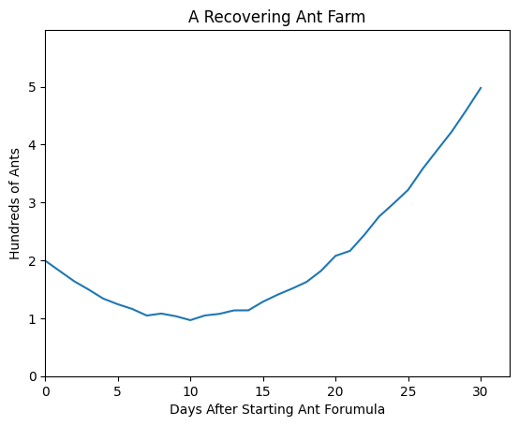

1. What’s the lowest point in the population? What part of the quadratic does that correspond to? After how long does it happen?

*The lowest population happens at about 100 ants at 10 days into giving them the formula. This is the vertex of the quadratic.*

2 . Why do you think the ant population initially goes down?

*If the ants weren’t being properly taken care of by your sister there may be some ants who were alive but are too injured to survive. Even if the others are getting better, these ants still need to die before the numbers can improve.*

3. Why do you think the lines are not perfectly straight?

*There are two reasons:*

1. *Since we are estimating the population, not actually counting each time, there will always be some error in the measurement*
2. *The parabola is a model for the population and will never be able to perfectly predict the population change. There will always be external or unexpected factors that might alter slightly the results (e.g. one ant kills another)*

4. You notice that it looks a lot like a quadratic. Write an *approximate* formula for the graph. Explain.

Remember that a quadratic form in vertex form can be written:

Where:

* the vertex occurs at (h, k)
* a is a factor of that tells how much the population grows with the formula

*First, let’s define the function, P (the ant population in hundreds) as a function d (days after you start giving the ants the formula). We can see that the bottom of the curve, the vertex. In question 1, we found that the vertex was at (10, 1). Using vertex form, we get: P = a(d - 10) + 1. We just need to find a. We can see that when you got the ant farm (d=0), there were 200 ants, giving us the point (0, 2). We can plug in and solve for a:*

*P(0) = 2 = a(0 - 10)^2 + 1 → 1 = 100a → a = .*

*This gives us the final equation:*

### The Parabolic Mirror

Did you know that the Olympic torch is traditionally lit with a mirror? How is that possible? Well, it’s not just any mirror, it’s a *parabolic mirror*, a mirror shaped like a parabola. See the pictures[3],[4] below.

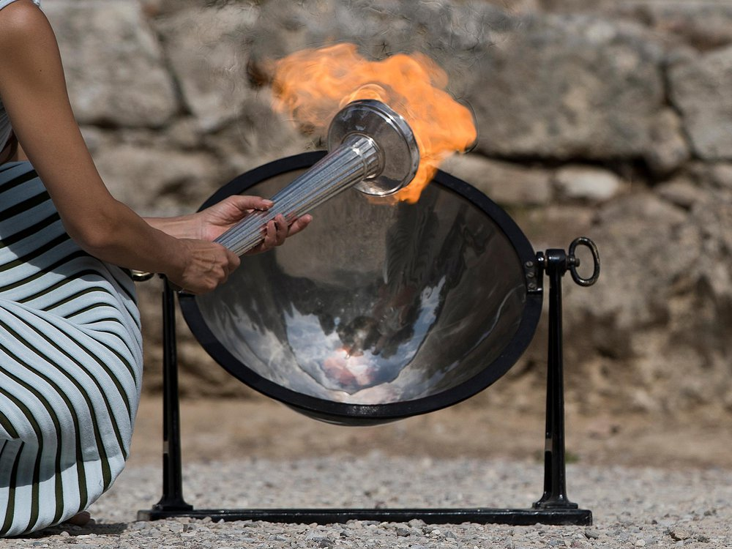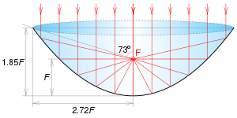

Parabolas have an important property called the *focal point*, and while exactly how this works is beyond the scope of our class, we can think of the *focal point* as the place where the incident light is most concentrated. So, if the sunlight enters the parabolic mirror, the *focal point* is where we will most feel the heat of the sun when the light is reflected back. If we locate our unlit torch at the *focal point* (F in the diagram above) of the mirror, the high intensity light will heat it up until it lights! Understanding the *focal point* of mirrors and lenses is part of the study of *optics*.

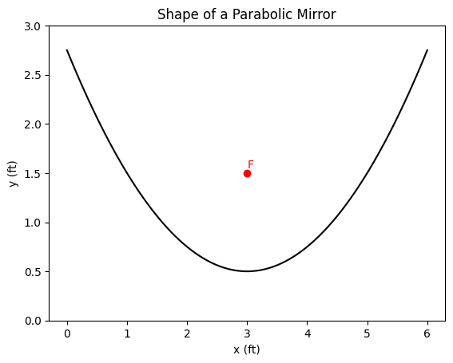

Now, imagine we have a lens with the shape of the lens to the right. With the following equation:

1. What are the coordinates of the *vertex* of our mirror?

*The vertex, being the lowest point, is at (3, ½). This can be taken from the graph or from knowing that in vertex form, the 3 inside the parenthesis is the x-coordinate and the ½ added at the end is the y-coordinate.*

2. The *focal point* can be found (known as the focal length) above the lowest point of the lens, where *a* is the typical *a* from quadratic equations. Find the focal length of our parabolic mirror.

*From the equation, we see that a is ¼. So, f = so the focal length is 1.*

3. At what coordinate should the tip of the torch be held in order to light it? Draw it on the given graph and label it F.

*F is going to be found at* ***f*** *feet above the vertex. So the coordinates should be (3, ½ +* ***f****)**= (3, ½ +* ***1****) = (3, 1.5)*

1. Information from New York State Health Dept: https://www.health.ny.gov/environmental/indoors/air/pmq_a.htm#:~:text=Fine%20particulate%20matter%20(PM2.5,hazy%20when%20levels%20are%20elevated.
2. AQI information and graphic can be found here: https://www.airnow.gov/aqi/aqi-basics/
3. Image 1 from: <https://www.smithsonianmag.com/innovation/your-burning-questions-about-olympic-torch-answered-180968120/>
4. Image 2 from <https://en.wikipedia.org/wiki/Parabolic_reflector>